How to pull develop code into your feature branch

You should ***pull*** the develop branch frequently into your feature branch to get the latest changes from develop and minimize the amount of code conflicts that could occur when you are ready to push your feature branch to the remote on github.

The steps to do this are:

1. Make sure you are currently working on your feature branch.

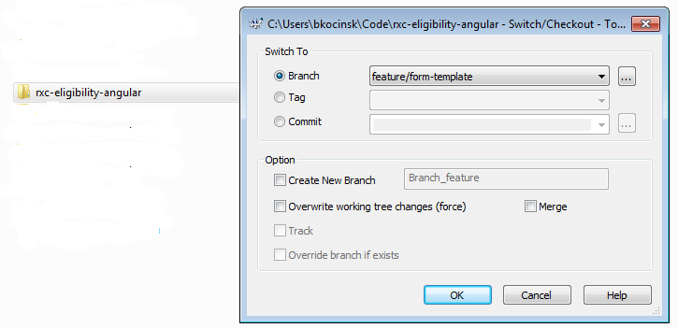

1. Use TortoiseGit to pull from the develop branch of the remote repository. Pull will download the changes from the remote branch you select as well as try to merge them into your feature branch.

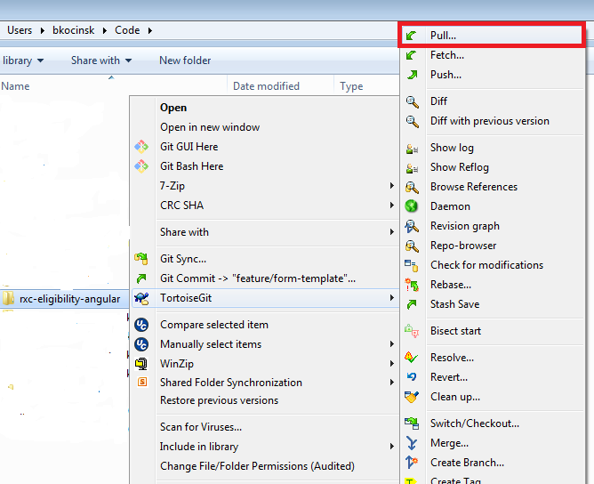

If develop does not show up in the dropdown, click on the … button to see more branches.

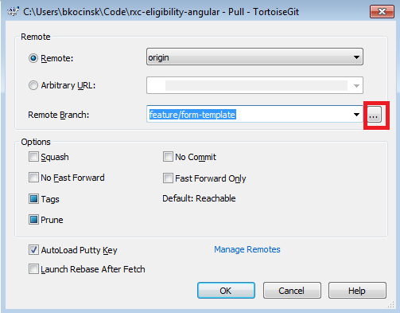

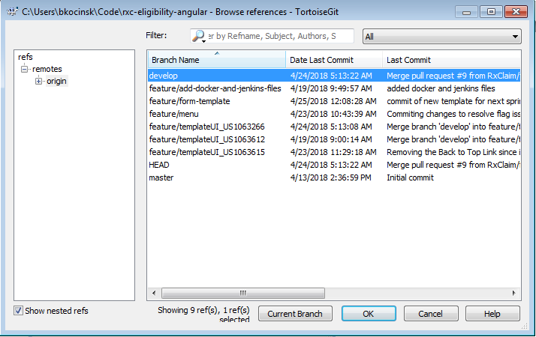

Or just type develop into the dropdown and click on ok.

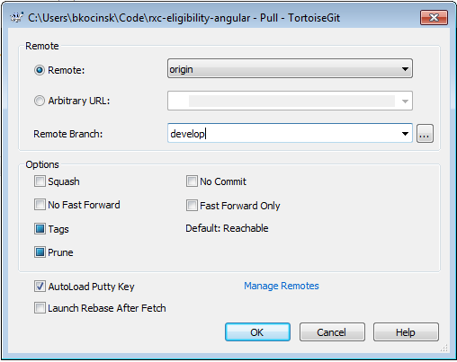

1. After the code is pulled down and merged you can click on the Pull Diff button to see what got changed.

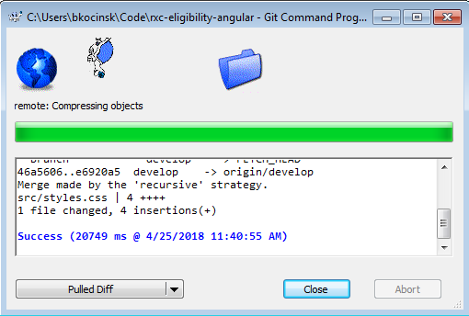

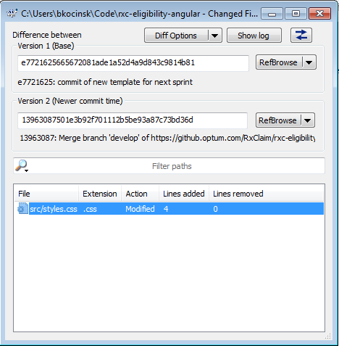

1. If you encounter conflicts during the pull process, git will add lines similar to the following in your code.

<html>

<head>

**<<<<<<< HEAD**

<link type="text/css" rel="stylesheet" media="all" href="optum_style.css" />

**=======**

<link type="text/css" rel="stylesheet" media="all" href="style.css" />

**>>>>>>> develop**

</head>

<body>

… (body contents)…

</body>

</html>

This is your code:

<<<<<<< HEAD

<link type="text/css" rel="stylesheet" media="all" href="optum_style.css" />

This is the code in the develop branch:

<link type="text/css" rel="stylesheet" media="all" href=" style.css" />

>>>>>>> develop

You need to manually fix this code yourself to get the desired result you intended. The fixed

code would look like this:

<html>

<head>

<link type="text/css" rel="stylesheet" media="all" href="optum_style.css" />

</head>

<body>

… (body contents)…

</body>

</html>

You should then repeat this process for any other conflicts.

1. Rebuild and retest your code, then push your feature branch up to the remote and issue a pull request so it can be reviewed and merged into develop.